New Year Drinks Reception

Transport Planning & Public Health

18:00, Thursday 7th January 2016

Palmer Room, Institution of Civil Engineers, One Great George Street, London, SW1p 3AA

The TPS Board invite you to start the new year by enjoying a glass of wine or soft drink and catching up with our members, the TPS Board and our guest speaker Lucy Saunders, Transport Planner of the Year 2015.

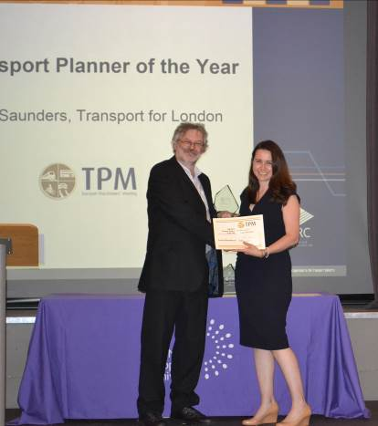
Lucy Saunders is the Public Health Specialist in Transport and Public Realm for Transport for London (TfL) and the Greater London Authority. Through her public health training and career Lucy recognised that the transport system, including street environments, has the biggest realisable potential for improving health in urban areas. Lucy joined TfL in 2012 and leads on the integration of transport and public health in London supporting teams across Transport for London and boroughs and working with advocacy organisations. Lucy wrote and leads on the implementation of TfL’s Health Action Plan which is the first plan of its kind worldwide, published in 2014. In 2015 Lucy’s work received several national and international awards and she was awarded Transport Planner of the Year.

There will be plenty of opportunity to ask questions, to put forward your own thoughts about how the transport profession has changed over the years, to discuss what’s in store for the future and to let us know what the Society can do for you.

To book your place at this event please visit https://www.ice.org.uk/events/private-events/new-year-drinks-reception If you do not currently have access to a MyICE account please register and this will allow you to book yourself on all future TPS events. Please note if you are a Corporate/Stakeholder member of TPS you will need to register as a non-member rather than a member as the membership number relates to ICE not TPS.

If you require advice or are unable to book yourself on this event please contact Pauline Arundel on pauline.arundel@ice.org.uk or 020 7665 2236.

Please note that entrance to the event is free for TPS and RTPI members. A £10 fee applies to non-members.

